International conference PTUJ, 15-17. May 2019
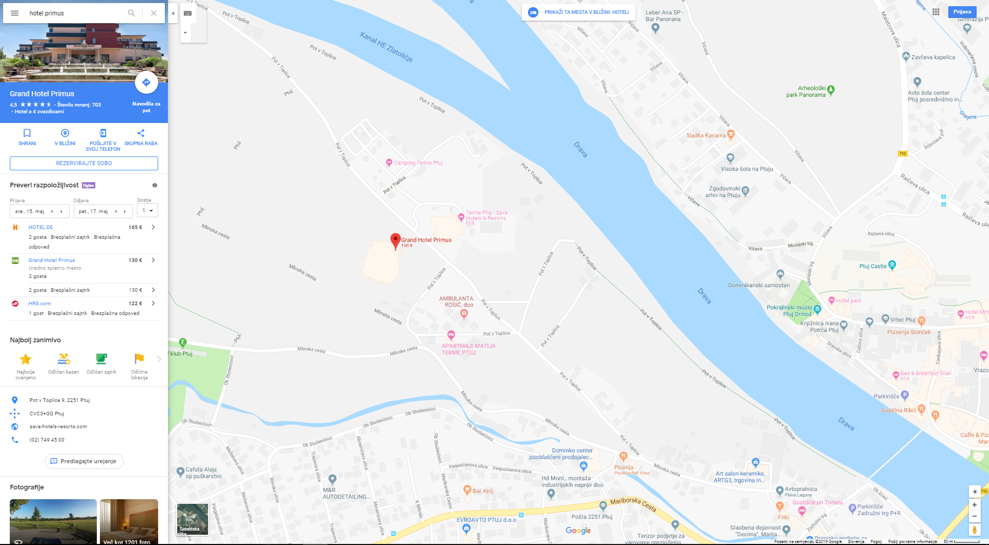
The International Conference will be held at the Grand Hotel Primus, in Slovenian oldest city - Ptuj (Pot v Toplice 9, 2251 Ptuj, Slovenia)

The hotel is marked with green circle. The red circles on all other maps represent the nearby accommodations.
Hotel Primus:
Price for ONE NIGHT WITH BREAKFAST per day per person – special price for the event:
Single room with one bed for one person (‘single use’) 97,00 EUR / per person per day
Double bed room for two persons (double in twin room) 74,00 EUR / per person per day

Price for TWO NIGHTS WITH BREAKFAST per person per day – special price for the event:
Single room with one bed for one person (‘single use’) 91,00 EUR / per person per day
Double bed room for two persons (double in twin room)) 66,00 EUR / per person per day

Hotel & Casinò Poetovio
https://www.booking.com/searchresults.en-gb.html?aid=311984;label=hotel-40563-si-YuJ_MyZbQd9VOz6ApbK2BAS86580677805%3Apl%3Ata%3Ap1%3Ap21%2C093%2C000%3Aac%3Aap1t1%3Aneg%3Afi%3Atikwd-8649072367%3Alp9062551%3Ali%3Adec%3Adm;sid=ca56675cb0b72721a5ab96bd69e221d6;checkin=2019-05-13;checkout=2019-05-14;city=-93438;highlighted_hotels=488318;hlrd=with_av;keep_landing=1;redirected=1;source=hotel;srpvid=391c48ea09eb018e&#hotelTmpl
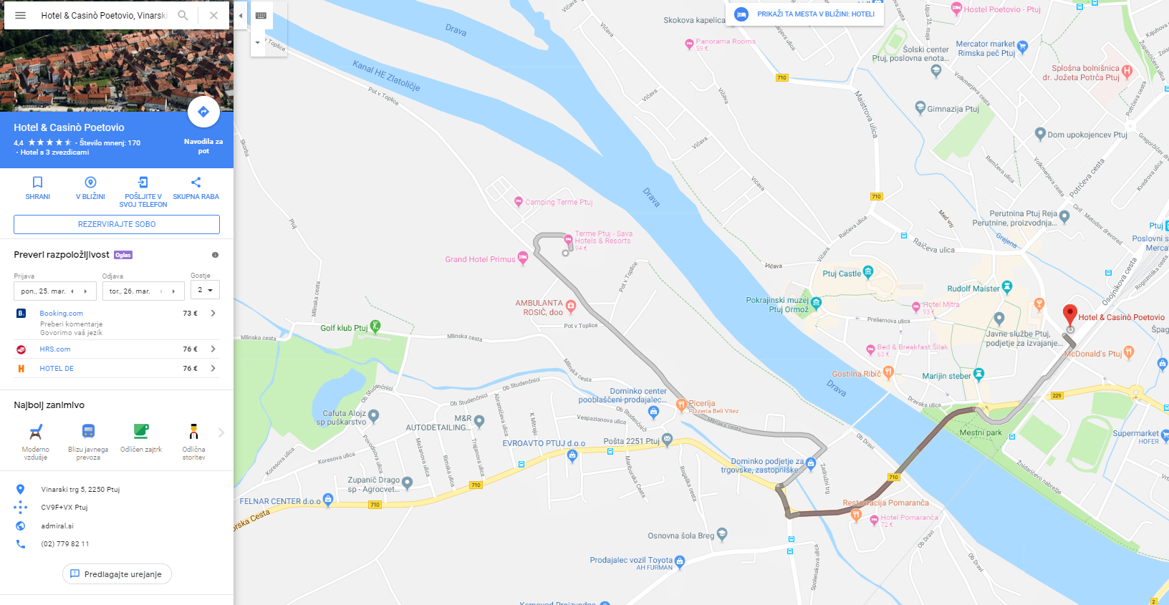
Address: Vinarski trg 5, 2250 Ptuj
Phone number: +386 02 779 82 11

Distance between accommodation and the conference:
- by car: 5 min (2,6 km)
- walk distance: 28 min (2,2 km)

Cost: apartment with two bed-rooms with breakfast from 44,60 € on

Hotel Mitra
https://www.booking.com/hotel/si/mitra.en-gb.html?aid=311984;label=hotel-40563-si-YuJ_MyZbQd9VOz6ApbK2BAS86580677805%3Apl%3Ata%3Ap1%3Ap21%2C093%2C000%3Aac%3Aap1t1%3Aneg%3Afi%3Atikwd-8649072367%3Alp9062551%3Ali%3Adec%3Adm;sid=bd1c940f95abb1dd92f3258f94188225;all_sr_blocks=3998805_124525764_1_1_0;checkin=2019-05-13;checkout=2019-05-14;dest_id=-93438;dest_type=city;dist=0;group_adults=1;group_children=0;hapos=8;highlighted_blocks=3998805_124525764_1_1_0;hpos=8;no_rooms=1;req_adults=1;req_children=0;room1=A;sb_price_type=total;sr_order=popularity;srepoch=1553163785;srpvid=1da1490436250020;type=total;ucfs=1&#hotelTmpl
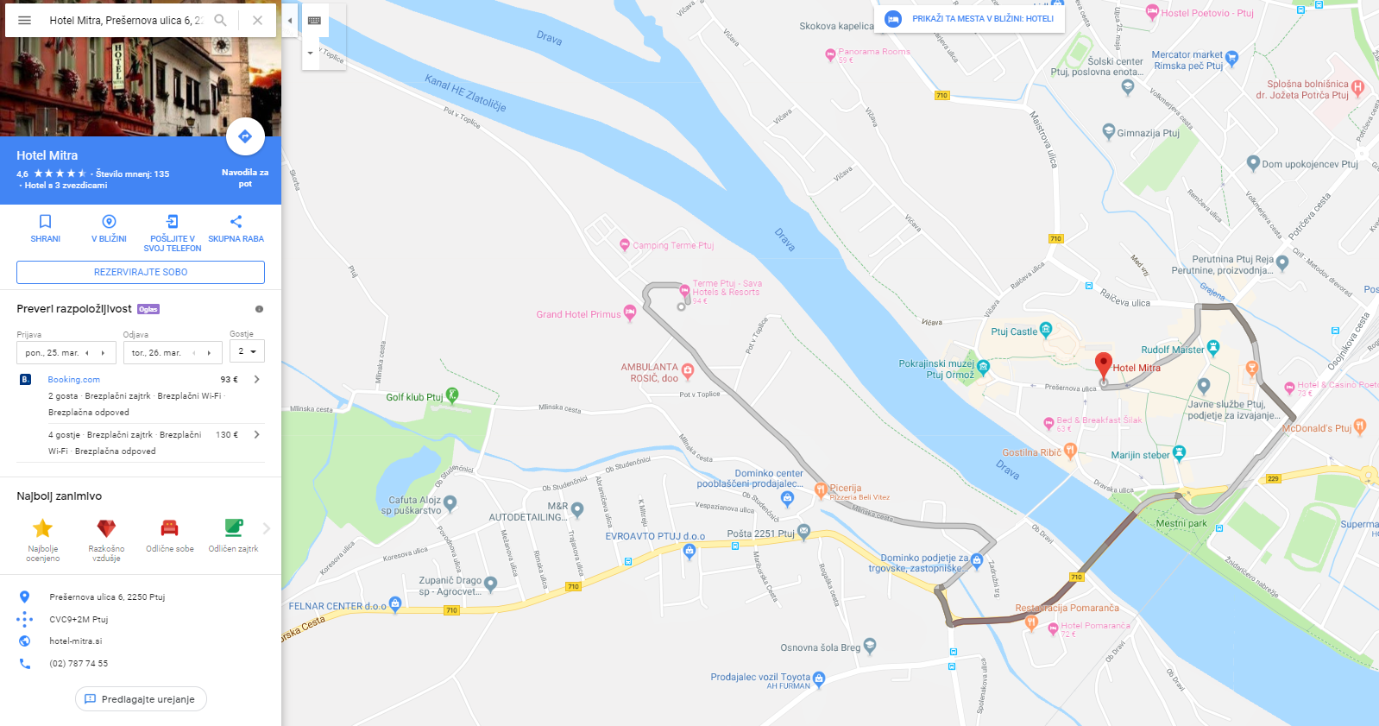
Address:Prešernova ulica 6, 2250 Ptuj
Phone number: +386 (02) 787 74 55

Distance between accommodation and the conference:
- by car: 10 min (3,3 km)
- walk distance: 22 min (1,7 km)

Cost: apartment with two bed-rooms with breakfast from 68,50 € on

Apartments Matija Terme Ptuj
https://www.apartma-ptuj.si/ or https://www.booking.com/hotel/si/apartment-matija-ptuj.sl.html?aid=357026;label=gog235jc-1DCAsoywFCFWd1ZXN0aG91c2UtcHJpLXRvbmV0dUgjWANoywGIAQGYASO4ARfIAQ7YAQPoAQH4AQKIAgGoAgO4AuinnuQFwAIB;sid=b56ce7f0e9d004da71c6aff842b83005;all_sr_blocks=222764602_128546213_4_0_0;checkin=2019-05-15;checkout=2019-05-17;dist=0;group_adults=1;group_children=0;hapos=1;highlighted_blocks=222764602_128546213_4_0_0;hpos=1;no_rooms=1;req_adults=1;req_children=0;room1=A;sb_price_type=total;sr_order=distance_from_search;srepoch=1552389582;srpvid=eca94fa62060008f;type=total;ucfs=1&#hotelTmpl
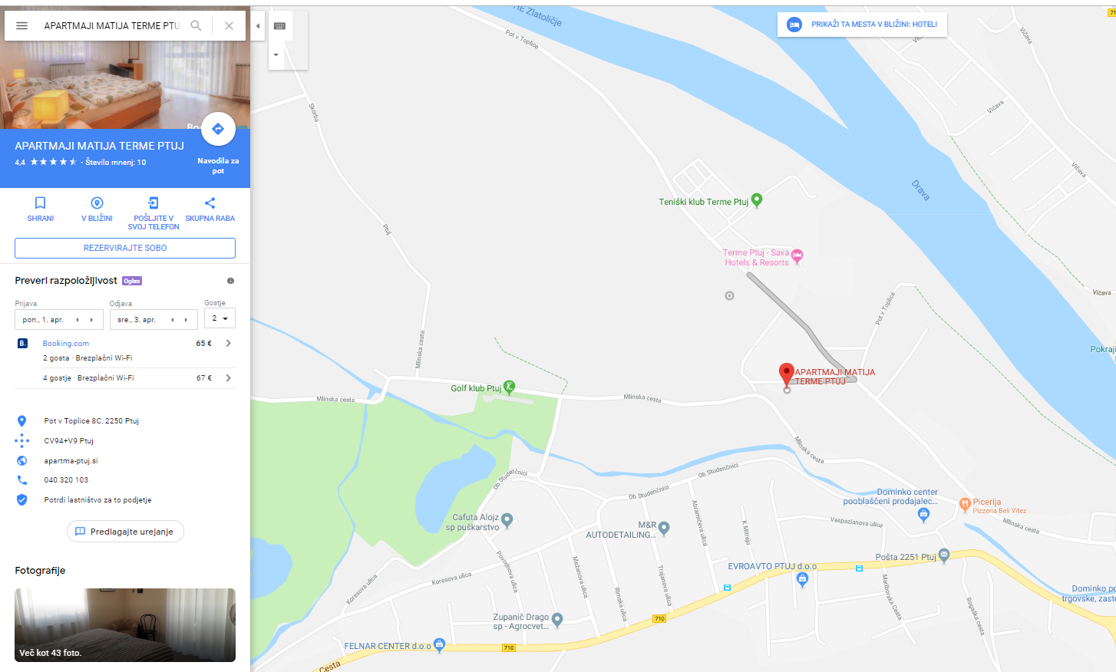
Address: Pot v toplice 8C, 2250 Ptuj
Phone number: +386 40 320 103

Distance between accommodation and the conference:
- walk distance: it is 0,1 km away

Cost: apartment with two bed-rooms with breakfast from 130,20 € on

Gostišče pri Tonetu
https://www.gostisce-svensek.si/ or https://www.booking.com/hotel/si/guesthouse-pri-tonetu.sl.html?aid=357026;label=gog235jc-1DCAsoywFCFWd1ZXN0aG91c2UtcHJpLXRvbmV0dUgjWANoywGIAQGYASO4ARfIAQ7YAQPoAQH4AQKIAgGoAgO4AuinnuQFwAIB;sid=b56ce7f0e9d004da71c6aff842b83005;all_sr_blocks=177104107_142089132_1_2_0;checkin=2019-05-15;checkout=2019-05-17;dest_id=-93438;dest_type=city;dist=0;group_adults=1;group_children=0;hapos=1;highlighted_blocks=177104107_142089132_1_2_0;hpos=1;no_rooms=1;req_adults=1;req_children=0;room1=A;sb_price_type=total;sr_order=popularity;srepoch=1552389214;srpvid=c04f4eefa52e0559;type=total;ucfs=1&#hotelTmpl
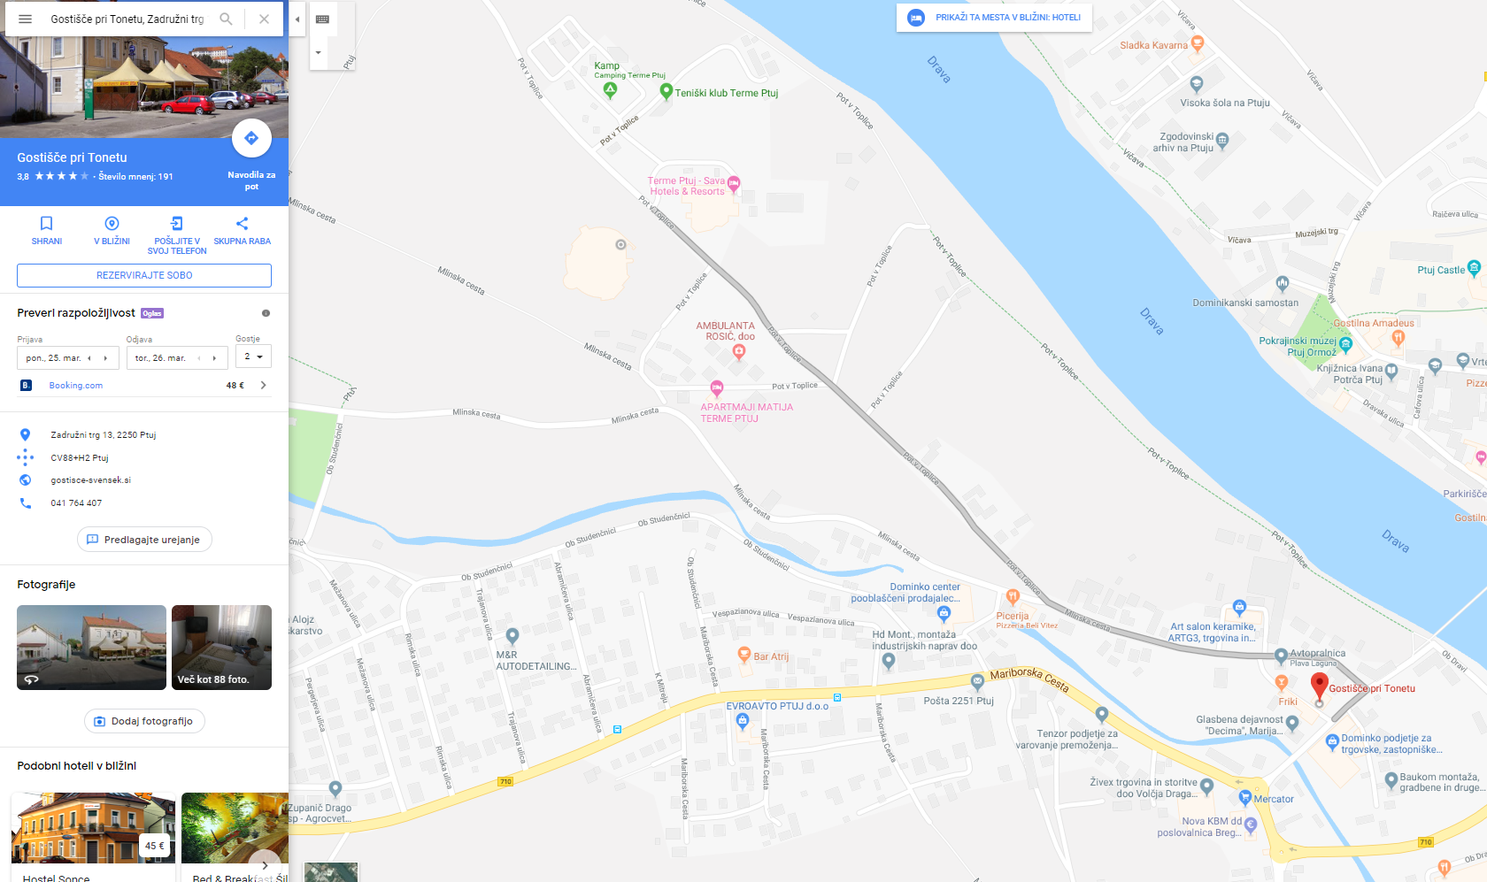
Address: Zadružni trg 13, 2250 Ptuj
Phone number: +386 41 764 407
Distance between accommodation and the conference:
- by car: 2 min (1,1km)
- walking distance: between 12 and 16 min (1,1 km)

Cost: room with one bed with breakfast from 44 € on

Hotel Pomaranča
https://hotel-pomaranca.si/index.php/sl/ or https://www.booking.com/hotel/si/pomaranca.sl.html?aid=376443;label=booking-name-0o_tGeeKvRSGC252vxHgkgS267724711560%3Apl%3Ata%3Ap1%3Ap22%2C259%2C000%3Aac%3Aap1t1%3Aneg%3Afi%3Atiaud-294889295693%3Akwd-65526620%3Alp9062551%3Ali%3Adec%3Adm;sid=ca56675cb0b72721a5ab96bd69e221d6;all_sr_blocks=181615903_133586029_1_1_0;checkin=2019-05-15;checkout=2019-05-17;dest_id=-93438;dest_type=city;dist=0;group_adults=1;group_children=0;hapos=1;highlighted_blocks=181615903_133586029_1_1_0;hpos=1;no_rooms=1;req_adults=1;req_children=0;room1=A;sb_price_type=total;sr_order=popularity;srepoch=1552564834;srpvid=344e5470fed80009;type=total;ucfs=1&#hotelTmpl
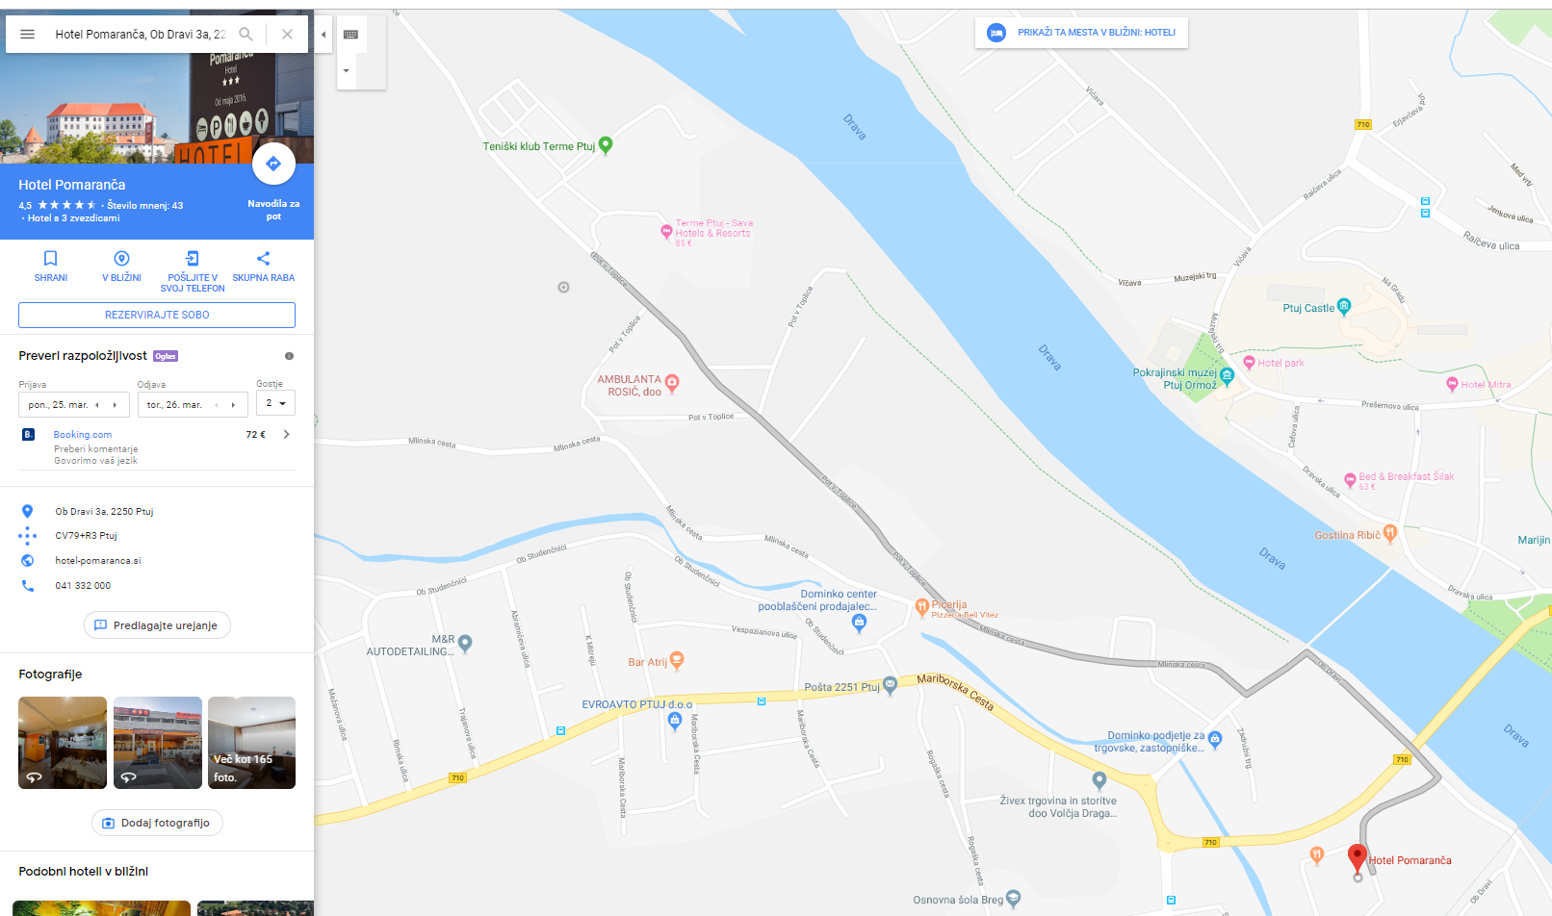
Address: Ob Dravi 3a, 2250 Ptuj
Phone number: 040 320 103

Distance between accommodation and the conference:
- by car: 3 min (1,5 km)
- walking distance: 20 min (1,5 km)

Cost: room with one bed with breakfast from 84 € on

Panorama Rooms
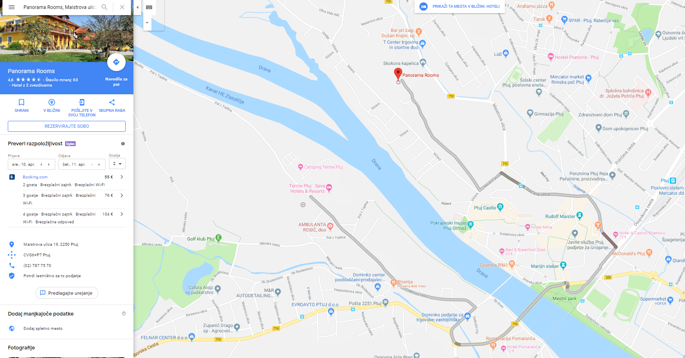
http://www.visitptuj.eu/en/partners/item/94-oddaja-sob-panorama or https://www.booking.com/hotel/si/panorama-metka-gutschi-s-p.sl.html?aid=376443;label=booking-name-0o_tGeeKvRSGC252vxHgkgS267724711560%3Apl%3Ata%3Ap1%3Ap22%2C259%2C000%3Aac%3Aap1t1%3Aneg%3Afi%3Atiaud-294889295693%3Akwd-65526620%3Alp9062551%3Ali%3Adec%3Adm;sid=ca56675cb0b72721a5ab96bd69e221d6;all_sr_blocks=46837902_141478156_0_1_0;checkin=2019-05-15;checkout=2019-05-17;dist=0;group_adults=1;group_children=0;hapos=2;highlighted_blocks=46837902_141478156_0_1_0;hpos=2;req_adults=1;req_children=0;room1=A;sb_price_type=total;sr_order=distance_from_search;srepoch=1552563876;srpvid=2748529182f9027c;type=total;ucfs=1&#hotelTmpl
Address: Maistrova ulica 19, 2250 Ptuj

Phone number: +386(0)27877570 / 71

Distance between accommodation and the conference:
- by car: 8 min (4 km)
- walking distance: 30 min (2,6 km)

Cost: room with one bed with breakfast from 66,60 € on

If you do not prefer any of the above mentioned accommodations, we advise you to check the booking site (the place of the Hotel Primus and the conference date are set for you) https://www.booking.com/index.sl.html?aid=376443&label=booking-name-0o_tGeeKvRSGC252vxHgkgS267724711560%3Apl%3Ata%3Ap1%3Ap22%2C259%2C000%3Aac%3Aap1t1%3Aneg%3Afi%3Atiaud-294889295693%3Akwd-65526620%3Alp9062551%3Ali%3Adec%3Adm&sid=ca56675cb0b72721a5ab96bd69e221d6&srpvid=2748529182f9027c&click_from_logo=1

